RANK | EARLY & MIDDLE GRADE
- A Wolf Called Fire
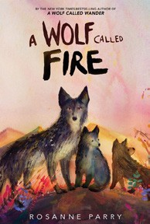



Rosanne Parry, Mónica Armiño (Illus.), Greenwillow Books, $18.99
- Impossible Creatures
Katherine Rundell, Ashley Mackenzie (Illus.), Knopf Books for Young Readers, $19.99
- The Squad: A Graphic Novel
Christina Soontornvat, Joanna Cacao (Illus.), Graphix, $12.99
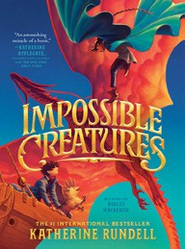

- The New Girl: A Graphic Novel
Cassandra Calin, Graphix, $12.99
- Warriors Graphic Novel #1
Erin Hunter, Natalie Riess (Illus.), Sara Goetter (Illus.), HarperAlley, $15.99
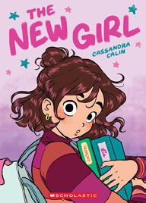

- Away
Megan E. Freeman, Aladdin, $18.99
- Bluey 5-Minute Stories
Penguin Young Readers, $14.99
- Super Duper Extra Deluxe Essential Handbook (Pokémon)
Scholastic, $16.99
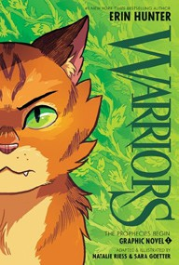

- The Bletchley Riddle
Ruta Sepetys, Steve Sheinkin, Viking Books for Young Readers, $18.99
- The Eyes and the Impossible
Dave Eggers, Shawn Harris (Illus.), Knopf Books for Young Readers, $19.99
- Drama: A Graphic Novel
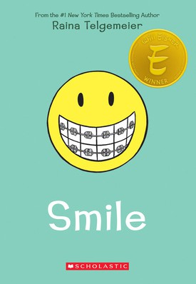

Raina Telgemeier, Graphix, $12.99
- The One and Only Bob
Katherine Applegate, Patricia Castelao (Illus.), Harper, $10.99
- Hatchet
Gary Paulsen, Simon & Schuster Books for Young Readers, $9.99
- Sisters: A Graphic Novel
Raina Telgemeier, Graphix, $12.99
- Smile: A Graphic Novel
Raina Telgemeier, Graphix, $12.99
February 26, 2025
For the week ending February 23, 2025 based on sales in hundreds of independent bookstores nationwide.
CHILDREN’S

RANK | YOUNG ADULT
  - Rebel Witch: The Crimson Moth: Book 2
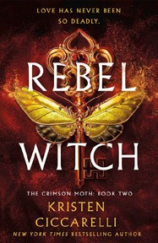

Kristen Ciccarelli, Wednesday Books, $20
  - Wings of Starlight
Allison Saft, Disney Press, $18.99
  - Powerless
Lauren Roberts, Simon & Schuster Books for Young Readers, $19.99
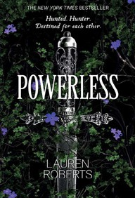

  - Heavenly Tyrant
Xiran Jay Zhao, Tundra Books, $20.99
  - Better Than the Movies
Lynn Painter, Simon & Schuster Books for Young Readers, $12.99
  - If He Had Been with Me
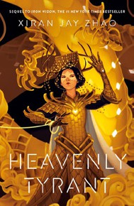

Laura Nowlin, Sourcebooks Fire, $10.99
  - All Better Now
Neal Shusterman, Simon & Schuster Books for Young Readers, $21.99
  - Under the Same Stars
Libba Bray, Farrar, Straus and Giroux BYR, $24.99
  - The Perks of Being a Wallflower
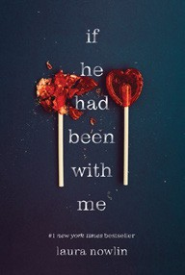

Stephen Chbosky, MTV Books, $15.99
  - Nothing Like the Movies
Lynn Painter, Simon & Schuster Books for Young Readers, $19.99
  - Iron Widow
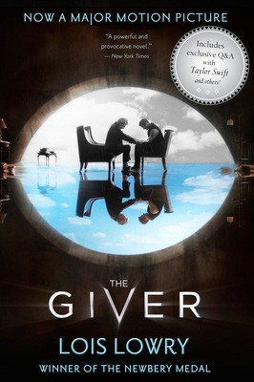

Xiran Jay Zhao, Tundra Books, $11.99
  - The Giver
Lois Lowry, Clarion Books, $11.99
  - Heartless Hunter: The Crimson Moth: Book 1
Kristen Ciccarelli, Wednesday Books, $20
  - Legendborn
Tracy Deonn, Margaret K. McElderry Books, $13.99
  - The Book Thief
Markus Zusak, Knopf Books for Young Readers, $14.99

Debut


OTHER CHILDREN’S INDIE FAVORITES ^{Indies} ^{Introduce}
AGES 8 TO 12 TEEN READERS
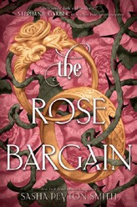

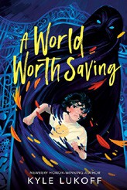

A World Worth Saving
Kyle Lukoff, Dial Books, $18.99
“A is a compelling narrator in a whirlwind adventure navigating trans identity, discrimination, and fighting off demons with his Golem and friends. This book is so generous and nuanced in its depiction of characters and is hopeful in its honesty.”
—Hannah Amrollahi, The Bookworm of Omaha, Omaha, NE
The Rose Bargain
Sasha Peyton Smith, HarperCollins, $19.99
“I am obsessed with this book and cannot stop talking about it even weeks after reading it. Set in an alternate Victorian era
England, The Rose Bargain is gripping from the very first page.”
—Tara Leimkuehler, Parnassus Books, Nashville, TN

