RANK | EARLY & MIDDLE GRADE
- Impossible Creatures
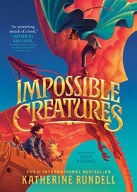



Katherine Rundell, Ashley Mackenzie (Illus.), Knopf Books for Young Readers, $19.99
- The Squad: A Graphic Novel
Christina Soontornvat, Joanna Cacao (Illus.) Graphix, $12.99
- Warriors Graphic Novel: The Prophecies Begin #1
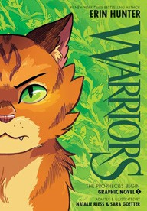

Erin Hunter, Natalie Riess (Illus.), Sara Goetter (Illus.), HarperAlley, $15.99
- The Bletchley Riddle
Ruta Sepetys, Steve Sheinkin, Viking Books for Young Readers, $18.99
- Super Duper Extra Deluxe Essential Handbook (Pokémon)
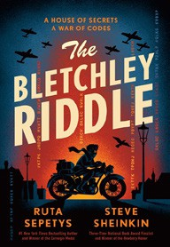

Scholastic, $16.99
- Scholastic Year in Sports 2025
James Buckley, Scholastic, $14.99
- The Millicent Quibb School of Etiquette for Young Ladies of Mad Science
Kate McKinnon, Little, Brown Books for Young Readers, $17.99
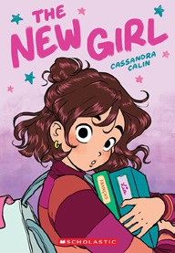

- The New Girl: A Graphic Novel
Cassandra Calin, Graphix, $12.99
- Fresh Start: A Graphic Novel
Gale Galligan, Graphix, $14.99
- Bluey 5-Minute Stories: 6 Stories in 1 Book? Hooray!
Penguin Young Readers, $14.99
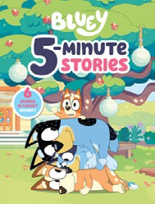

- Smile: A Graphic Novel
Raina Telgemeier, Graphix, $12.99
- Guts: A Graphic Novel
Raina Telgemeier, Graphix, $12.99
- The Eyes and the Impossible
Dave Eggers, Shawn Harris (Illus.), Knopf Books for Young Readers, $19.99
- Drama: A Graphic Novel
Raina Telgemeier, Graphix, $12.99
- The One and Only Bob

Katherine Applegate, Patricia Castelao (Illus.), Harper, $10.99
Debut
Indies Introduce
January 29, 2025
For the week ending January 26, 2025 based on sales in hundreds of independent bookstores nationwide.
CHILDREN’S

RANK | YOUNG ADULT
  - Heavenly Tyrant
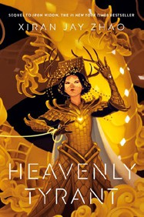

Xiran Jay Zhao, Tundra Books, $20.99
  - Iron Widow
Xiran Jay Zhao, Tundra Books, $11.99
  - Powerless
Lauren Roberts, Simon & Schuster Books for Young Readers, $19.99
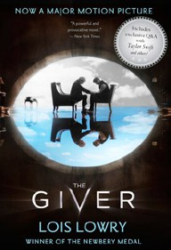

  - The Last Bookstore on Earth
Lily Braun-Arnold, Delacorte Press, $19.99
  - If He Had Been with Me
Laura Nowlin, Sourcebooks Fire, $10.99
  - The Giver
Lois Lowry, Clarion Books, $11.99
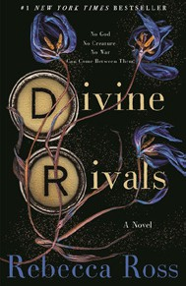

  - Better Than the Movies
Lynn Painter, Simon & Schuster Books for Young Readers, $12.99
  - Divine Rivals
Rebecca Ross, Wednesday Books, $18.99
  - The Perks of Being a Wallflower
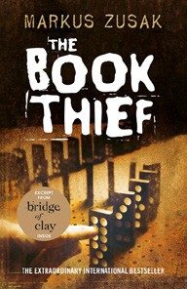

Stephen Chbosky, MTV Books, $15.99
  - Reckless
Lauren Roberts, Simon & Schuster Books for Young Readers, $21.99
  - Nothing Like the Movies
Lynn Painter, Simon & Schuster Books for Young Readers, $19.99
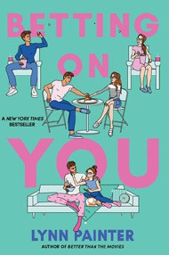

  - Pride and Prejudice
Jane Austen, Anna Bond (Illus.), Puffin Books, $17
  - The Book Thief
Markus Zusak, Knopf Books for Young Readers, $14.99
  - The Outsiders
S. E. Hinton, Viking Books for Young Readers, $14.99
  - Betting on You
Lynn Painter, Simon & Schuster Books for Young Readers, $12.99

OTHER CHILDREN’S INDIE FAVORITES
AGES 8 TO 12 TEEN READERS
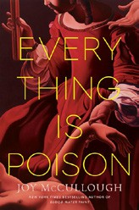

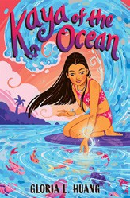

Kaya of the Ocean

Gloria L. Huang, Holiday House, $17.99
“An absolutely gorgeous story, shining a light on the very real struggles of growing up and feeling different. With incredibly heartfelt writing and a vivid setting, Kaya’s story can help young people that struggle with anxiety feel seen and heard.”
—Jonathan Pope, Prologue Bookshop, Columbus, OH
Everything Is Poison
Joy McCullough, Dutton Books for Young Readers, $19.99 “A captivating young adult historical novel told both in prose and in verse. Carmela has been patiently waiting for years for her mother to finally let her work in and learn the
mysteries of the apothecary. She’s soon learning all she can to help the people of Rome.”
—Jennifer Jones, Bookmiser, Marietta, GA

