RANK | EARLY & MIDDLE GRADE
- Impossible Creatures
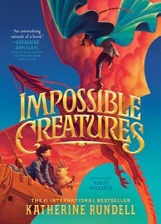



Katherine Rundell, Ashley Mackenzie (Illus.), Knopf Books for Young Readers, $19.99
- The Millicent Quibb School of Etiquette for Young Ladies of Mad Science
Kate McKinnon, Little, Brown Books for Young Readers, $17.99
- The Bletchley Riddle
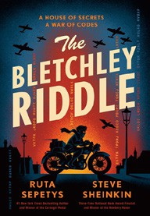

Ruta Sepetys, Steve Sheinkin, Viking Books for Young Readers, $18.99
- The Eyes and the Impossible
Dave Eggers, Shawn Harris (Illus.), Knopf Books for Young Readers, $19.99
- The Sherlock Society
James Ponti, Aladdin, $18.99
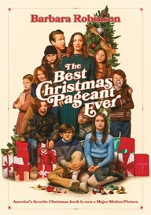

- Warriors Graphic Novel: The Prophecies Begin #1
Erin Hunter, Natalie Riess (Illus.), Sara Goetter (Illus.), HarperAlley, $15.99
- The Best Christmas Pageant Ever
Barbara Robinson, HarperCollins, $9.99
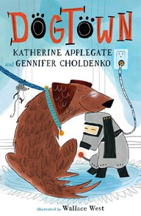
- The Squad: A Graphic Novel
Christina Soontornvat, Joanna Cacao (Illus.), Graphix, $12.99
- Orris and Timble: The Beginning
Kate DiCamillo, Carmen Mok (Illus.), Candlewick, $16.99
- Stella & Marigold
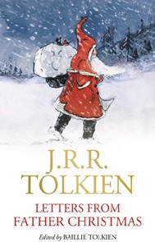
Annie Barrows, Sophie Blackall (Illus.), Chronicle Books, $15.99
- The Hotel Balzaar
Kate DiCamillo, Júlia Sardà (Illus.), Candlewick, $17.99
- The Last Dragon on Mars
Scott Reintgen, Aladdin, $18.99
- Dogtown
Katherine Applegate, Gennifer Choldenko, Wallace West (Illus.), Square Fish, $8.99
- Super Duper Extra Deluxe Essential Handbook (Pokémon)
Scholastic, $16.99
- Letters from Father Christmas

J.R.R. Tolkien, William Morrow, $28
Debut
Indies Introduce
December 18, 2024
For the week ending December 15, 2024 based on sales in hundreds of independent bookstores nationwide.
CHILDREN’S

RANK | YOUNG ADULT
  - Darkly
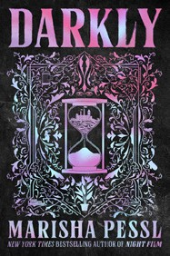

Marisha Pessl, Delacorte Press, $19.99
  - Heir
Sabaa Tahir, G.P. Putnam’s Sons Books for Young Readers, $21.99
  - Powerless
Lauren Roberts, Simon & Schuster Books for Young Readers, $19.99
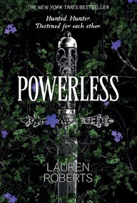

  - Better Than the Movies
Lynn Painter, Simon & Schuster Books for Young Readers, $12.99
  - Nothing Like the Movies
Lynn Painter, Simon & Schuster Books for Young Readers, $19.99
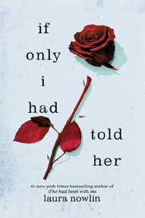

  - Pride and Prejudice
Jane Austen, Anna Bond (Illus.), Puffin Books, $17
  - If He Had Been with Me
Laura Nowlin, Sourcebooks Fire, $10.99
  - The Outsiders
S. E. Hinton, Viking Books for Young Readers, $14.99
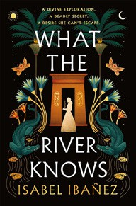

  - The Reappearance of Rachel Price
Holly Jackson, Delacorte Press, $20.99
  - If Only I Had Told Her
Laura Nowlin, Sourcebooks Fire, $12.99
  - The Book Thief
Markus Zusak, Knopf Books for Young Readers, $14.99
  - A Study in Drowning (Collector’s Deluxe Limited Edition)
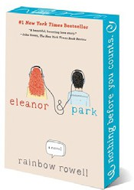

Ava Reid, HarperCollins, $21.99
  - What the River Knows
Isabel Ibañez, Wednesday Books, $20
  - Where the Library Hides
Isabel Ibañez, Wednesday Books, $20
  - Eleanor & Park
Rainbow Rowell, Wednesday Books, $15

OTHER CHILDREN’S INDIE FAVORITES
AGES 8 TO 12 TEEN READERS
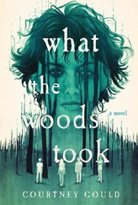

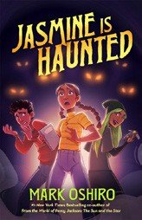

Jasmine Is Haunted
Mark Oshiro, Starscape, $18.99
“Latinx main characters! Age-appropriate LGBTQ+ themes! Paranormal activity! Mark Oshiro beautifully delivers this story of grief, moving on, and finding community who understands.”
—Karen Fiorini, Little Shop of Stories, Decatur, GA
What the Woods Took
Courtney Gould, Wednesday Books, $20
“Five teens are forced into a wilderness trek masqueraded as a cure to them being ‘troubled teens.’ When their guides disappear, they begin to suspect there’s something wrong in this forest. I couldn’t stop reading this deliciously dark and queer story.”
—Katlin Kerrison, Story on the Square, McDonough, GA

